Set 2 - Customer Satisfaction

- Histogram of Customer Ages
Code:
library(ggplot2)

customer_data <- data.frame(
Customer_ID = c(1, 2, 3, 4, 5),
Age = c(25, 30, 35, 28, 40),
Satisfaction_Score = c(4, 5, 3, 4, 5)
)

ggplot(customer_data, aes(x = Age)) +
geom_histogram(binwidth = 5, fill = "skyblue", color = "black") +
labs(
title = "Distribution of Customer Ages",
x = "Age",y = "Number of Customers") +theme_minimal()

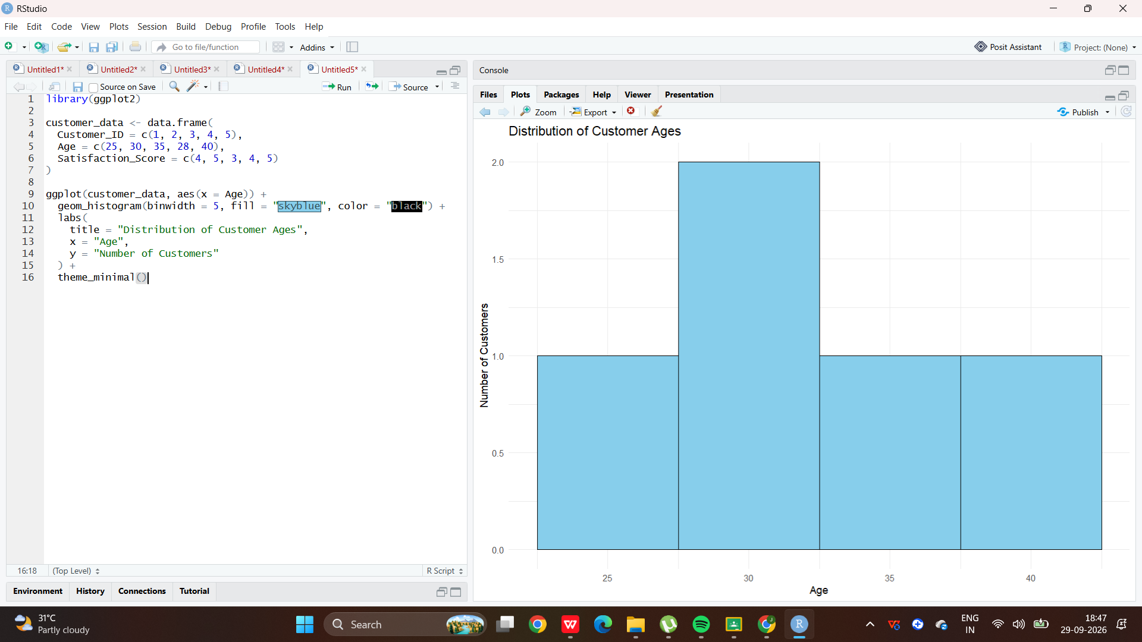

- Pie Chart of Satisfaction Scores
Code:
library(ggplot2)

satisfaction <- as.data.frame(table(customer_data$Satisfaction_Score))
colnames(satisfaction) <- c("Score", "Count")

ggplot(satisfaction, aes(x = "", y = Count, fill = Score)) +
geom_bar(stat = "identity", width = 1) +
coord_polar("y") +
labs(
title = "Customer Satisfaction Score Distribution",
fill = "Satisfaction Score"
) +
theme_void()

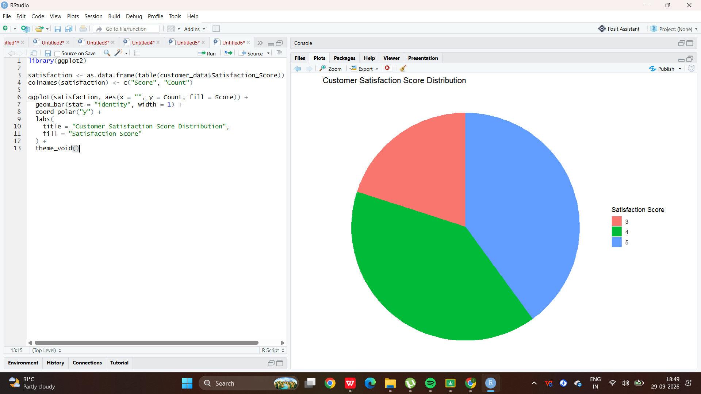

- Stacked Bar Chart of Satisfaction by Age Group
Code:
customer_data$Age_Group <- cut(
customer_data$Age,
breaks = c(20, 29, 39, 49),
labels = c("20-29", "30-39", "40-49")
)
ggplot(customer_data,
aes(x = Age_Group, fill = factor(Satisfaction_Score))) +geom_bar() +
labs(title = "Customer Satisfaction by Age Group", x = "Age Group",y = "Number of Customers",fill = "Satisfaction Score") +theme_minimal()
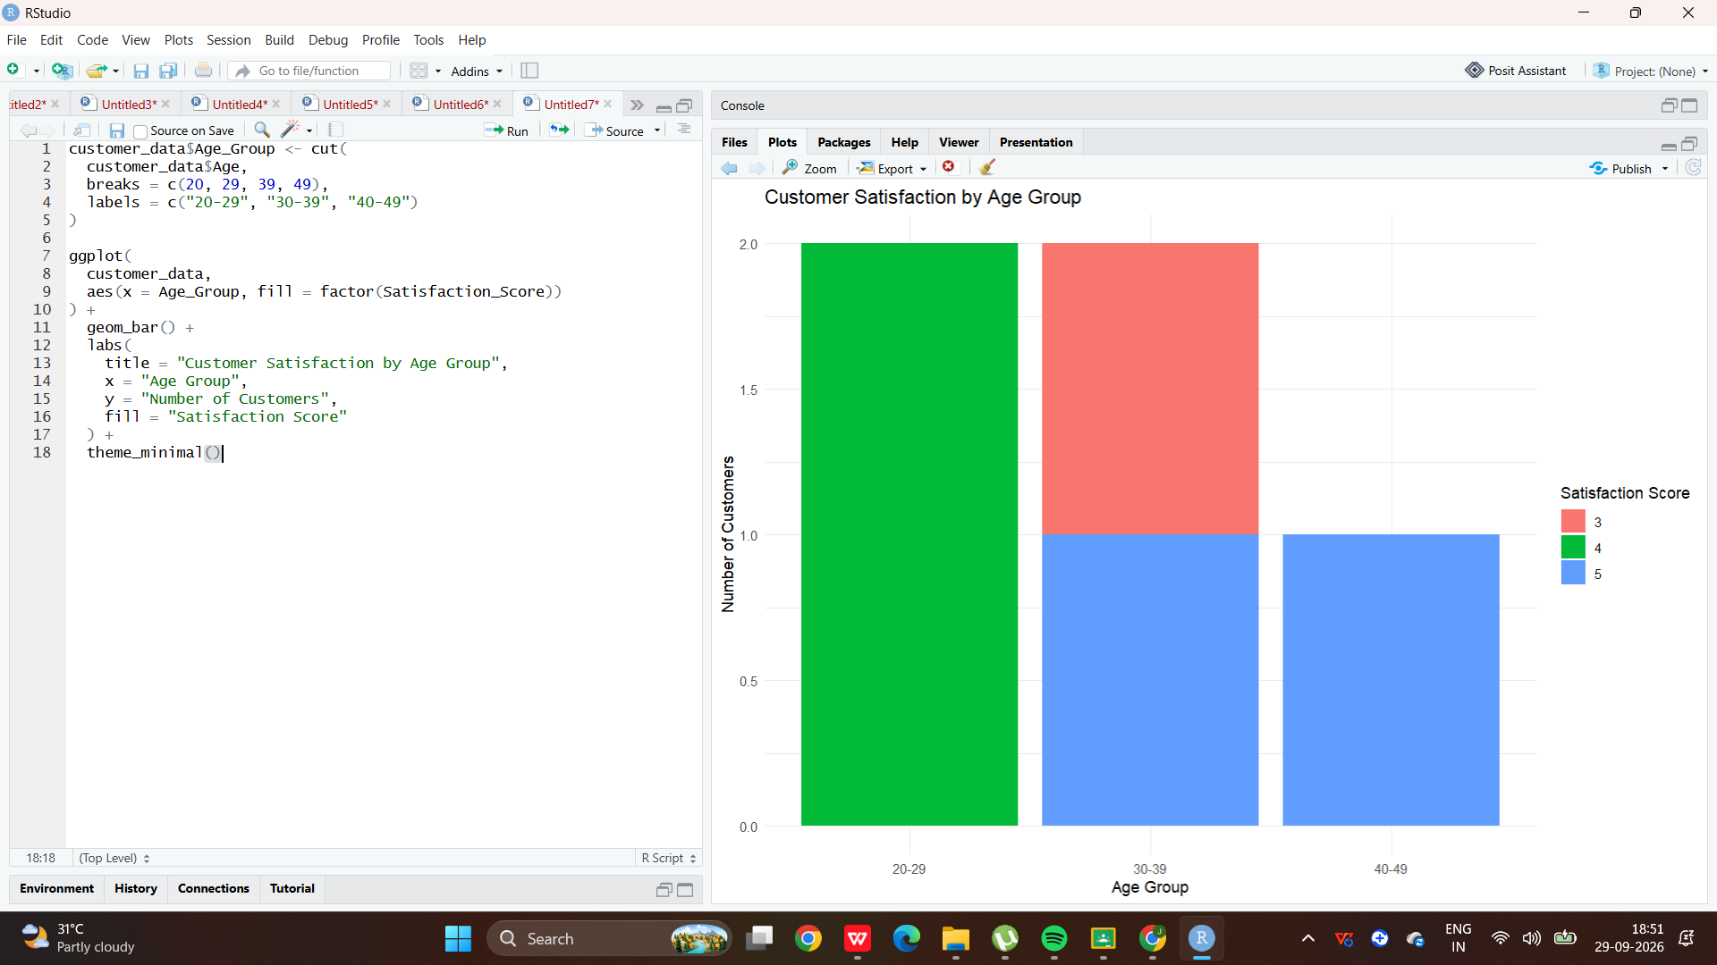
- Word Cloud of Customer Feedback
Code:
library(wordcloud)
library(RColorBrewer)

feedback <- c(
"Excellent service and friendly staff",
"Very satisfied with the product",
"Good quality and fast service",
"Excellent product",
"Friendly customer service",
"Very good experience",
"Satisfied with the quality",
"Fast delivery and excellent service",
"Good product but delivery was slow",
"Very happy with the service"
)

words <- tolower(paste(feedback, collapse = " "))

wordcloud(
words,
min.freq = 1,
max.words = 50,
random.order = FALSE,
colors = brewer.pal(8, "Dark2")
)
